 | International Cartographic Association  Commission on Cartography and Children  Barbara Petchenik Map Competition  Official permission | 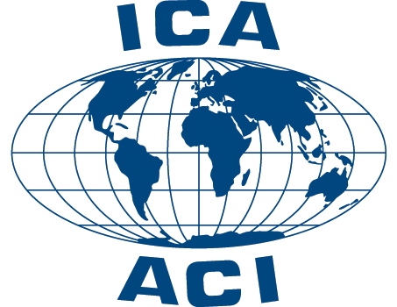

נא למלא בכתב קריא ומסודר, באנגלית באותיות גדולות, ובסוף חתימה ותאריך

Child’s family and first name:
.....................................................................................................................................
(Father’s / Mother’s / Legal representative’s)* family and first name:
.....................................................................................................................................

I / We* agree that my child’s drawing may be used, copied, reproduced, modified, reprinted, and publicly performed and displayed, in hard copy or digital formats, by the International Cartographic Association (ICA) or other international organizations/publishers for publication on behalf of the ICA without consultation or copyright/royalty fees.

Date: |  | Signature:

* Please, underline the appropriate option.

